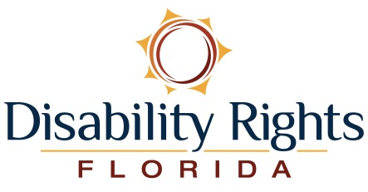 January 12, 2018

Representative Sam Johnson Representative John Larson
Chairman Ranking Member
Social Security Subcommittee Social Security Subcommittee
House Ways and Means Committee House Ways and Means Committee
2304 Rayburn House Office Building 1501 Longworth House Office Building
Washington, DC. 20515 Washington, DC. 20515

Dear Chairman Johnson and Ranking Member Larson:

On behalf of Disability Rights Florida, I write in strong support of H.R. 4547, the Strengthening Protections for Social Security Beneficiaries Act of 2017. Enactment of this legislation will provide critical protections for Social Security beneficiaries as well as needed reforms to the crucial representative payee program.

Disability Rights Florida is the State of Florida’s federally-designated Protection and Advocacy (P&A) system, benefitting individuals with disabilities through the provisions of free and confidential legal and advocacy services. In recent years, our organization has worked in partnership with the National Disability Rights Network to conduct important monitoring work of the ways in which the representative payee program and related designation is utilized in the state in an effort to safeguard against financial abuse and exploitation.

News stories, Office of Inspector General and Government Accountability Office reports, and hearings held by the House Ways and Means Committee have demonstrated the need for changes in the representative payee program. Your bipartisan legislation proposes many important and needed changes that will streamline the program as well as take important steps to increase oversight of the representative payee program by funding the nationwide network of P&A systems to monitor how representative payees are administering the Social Security funds received by beneficiaries.

Again, we greatly appreciate your work together on this important issue culminating in the introduction of this critical legislation. We stand ready to work with both of you to quickly get this important legislation enacted into law. Should you have any questions or need more information, please feel free to contact Tony DePalma, Director of Public Policy, at (850) 488-9071 or through email at tonyd@disabilityrightsflorida.org.

Sincerely,

Maryellen McDonald
Executive Director
Disability Rights Florida

